CALL FOR RADNET CITY OF LONDON 2021 DEVELOPMENT FUND
INFO FOR APPLICANTS

This document provides information on the CRUK RadNet City of London (CoL) Radiation Research Unit (RRU) Development Fund and guidelines on how to submit your project proposal form.

We are delighted to announce our 2021 development funding call to support established, cross-institutional collaborative groups who are tackling the major challenges in radiobiology and radio-oncology. Our strategic priority is to support studies that will provide preliminary data to leverage further substantive research funding or clinical trials.
Key points are:
- Development Fund awards for up to £20,000 are available
- Application Deadline: by end December 2020
- Projects are expected to commence in March 2021

Up to £5k increased budget limits will be considered only in very exceptional circumstances with appropriate justification.
For more information on RadNet activity, please visit our webpage: https://crukradnet.colcc.ac.uk/

- RadNet CoL RRU Overview
The RadNet CoL RRU brings together researchers from UCL, QMUL, KCL and the Francis Crick Institute in order to develop a world class hub for cancer biotherapeutics. Our mission is to improve cancer survival by optimising and personalising radiotherapy.

Our research focus is predicated on the view that cancer cure by radiotherapy can be improved by concentrating on the following core themes:
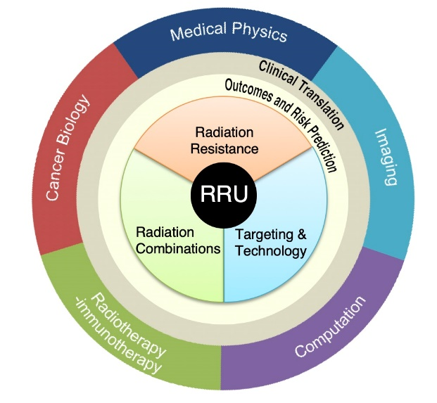
- Radiation resistance: To form a detailed mechanistic understanding of the roles of stem-like cancer cells, the tumour microenvironment and DNA damage and repair in clinical radiation resistance
- Radiation combinations: To understand the effect of radiotherapy on the immune response in the context of the entire tumour microenvironment with a view to synergistic combination therapies
- Targeting and technology: To match actual dose delivery of X-ray, proton or targeted radionuclide therapy to the true potential of radiotherapy technology and to predict and measure the outcome using novel biomarkers in addition to RECIST and survival.
These are supported by, and feed into, two cross-cutting themes:
- Outcomes and risk prediction: To build a comprehensive platform for radiotherapy data and apply artificial intelligence approaches to interrogate and predict clinical outcomes
- Clinical translation: To establish a clinical trials platform, the RadNet Trials Hub, to ensure a strong forward and reverse translational element to every theme, with input from patient and public involvement (PPI) members experienced in radiotherapy trials

- CRUK RadNet Centres of Excellence Overview
The CRUK CoL RRU forms part of a larger radiation network across the UK, called the CRUK RadNet Centres of Excellence. These include the 1) City of London Centre, 2) Cambridge, 3) ICR & RMH, 4) Glasgow, 5) Leeds, 6) Manchester & 7) Oxford. The Centres of Excellence serves as a platform for wider collaboration and synergy between research groups.
For more information on CRUK RadNet Centres of Excellence, please visit: https://www.cancerresearchuk.org/funding-for-researchers/our-research-infrastructure/radnet-our-radiation-research-network

- Research project requirements
Research project proposals for Seed Funding should:
- Address at least one of the above RadNet Themes
- Utilise at least one of RadNet’s sub-themes:
    - Cancer stem-like cell resistance
    - DNA damage & repair
    - Tumour microenvironment
    - Functional imaging
    - Molecular radiotherapy for children
    - Data Hub & predictive modelling
    - Digital pathology, genomics & AI
    - Clinical translation

- Timeline
Call for applications mid November 2020
Application deadline end December 2020
Selection of projects end January 2021
Project start date March 2021

Project proposals will be reviewed by a multi-disciplinary, cross-institutional panel to ensure they span the breadth of the City of London Centre RRU and fall within the RadNet research strategy. Projects will be ranked on criteria including scientific quality, strategic relevance and feasibility.

Faculty will be informed if their project will be funded by the end of January 2021.

- How to apply
- Complete the below attached Development Fund Application Form and return to: cruk-radnet-cityoflondon@ucl.ac.uk by end December 2020.
- Please direct any questions to Michelle Craft, RadNet City of London Project Manager, at: cruk-radnet-cityoflondon@ucl.ac.uk

CRUK RadNet City of London RRU Development Fund Application Form
Applications should not exceed two pages (excluding one multi-panel figure) and should be in Arial font, size 10.
- Project Details

Principal Investigator
(Name, Institution, Department, Research Group & email)
Co-Investigator(s)
(Name, Institution, Department, Research Group & email)
Project Title
(Should be understood by a non-specialist)

- Brief summary (maximum five lines)

- Background

- Proposal (including a breakdown of requested costs)

- Optional: justification for any additional costs over £20k (additional £5k limit)

- If applicable, please list other current funding and describe how those funds support this application (including sources that do not support radiation-based projects)

- Please explain how the Development Fund will help to secure longer term funding to support the project and/or the RadNET CoL RRU’s strategic direction.

- Please include five key references

- Please advise if you have applied to other CRUK Centre funding schemes with the same project (for a development fund and/or studentships).

In addition, a brief CV of the applicants should be provided (maximum one page per applicant).

