EXPRESSION OF INTEREST FOR
RADNET CITY OF LONDON CLINICAL ACADEMICS
INFO FOR APPLICANTS

This document provides information on the CRUK RadNet City of London (CoL) Radiation Research Unit (RRU) Clinical Academics Expression of Interest and guidelines for application.

We are seeking staff from our NHS Trust partners (Guy’s, Barts and UCLH), who have a major focus in radiation biology and/or radiation oncology research. We have clinical PAs available and wish to explore how their ambitions align with our strategy.

- CRUK RadNet CoL RRU Overview
CRUK RadNet CoL RRU brings together researchers from UCL, QMUL, KCL and the Francis Crick Institute in order to develop a world class hub for cancer biotherapeutics. Our mission is to improve cancer survival by optimising and personalising radiotherapy.

Our research focus is predicated on the view that cancer cure by radiotherapy can be improved by concentrating on the following core themes:
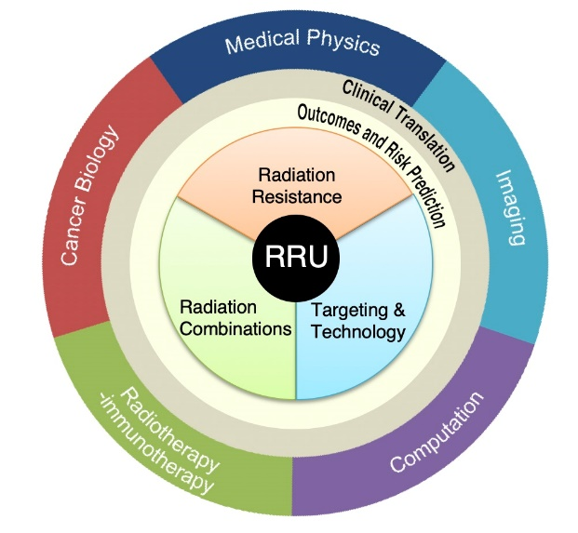
- Radiation resistance: To form a detailed mechanistic understanding of the roles of stem-like cancer cells, the tumour microenvironment and DNA damage and repair in clinical radiation resistance
- Radiation combinations: To understand the effect of radiotherapy on the immune response in the context of the entire tumour microenvironment with a view to synergistic combination therapies
- Targeting and technology: To match actual dose delivery of X-ray, proton or targeted radionuclide therapy to the true potential of radiotherapy technology and to predict and measure the outcome using novel biomarkers in addition to RECIST and survival.
These are supported by, and feed into, two cross-cutting themes:
- Outcomes and risk prediction: To build a comprehensive platform for radiotherapy data and apply artificial intelligence approaches to interrogate and predict clinical outcomes
- Clinical translation: To establish a clinical trials platform, the RadNet Trials Hub, to ensure a strong forward and reverse translational element to every theme, with input from patient and public involvement (PPI) members experienced in radiotherapy trials

- Clinical PA requirements
Proposals for clinical PAs should:
- Address at least one of the above RadNet Themes
- Utilise at least one of RadNet’s sub-themes:
    - Cancer stem-like cell resistance
    - DNA damage & repair
    - Tumour microenvironment
    - Functional imaging
    - Molecular radiotherapy for children
    - Data Hub & predictive modelling
    - Digital pathology, genomics & AI
    - Clinical translation

- Timeline
Call for Expression of Interest | mid Nov 2020
Application deadline | 31 Dec 2020
Selection of proposals | mid Jan 2021
Interviews/meeting | early Feb 2021
Expect to start | April 2021

Proposals will be reviewed by a multi-disciplinary, cross-institutional panel to ensure they span the breadth of the City of London Centre RRU and fall within the RadNet research strategy. Projects will be ranked on criteria including scientific quality, strategic relevance to involve the respective NHS partner and feasibility.

- How to apply
- Please complete the below Clinical PA Expression of Interest Form and return to: cruk-radnet-cityoflondon@ucl.ac.uk
- Please direct any questions to Michelle Craft, RadNet City of London Project Manager, at: cruk-radnet-cityoflondon@ucl.ac.uk

CRUK RadNet CoL RRU Clinical PA Expression of Interest Form
Please use Arial font, size 10.

- Project Details

Name
Role
Department
NHS Trust
Email

- Please provide a 1pg (maximum) summary of your proposed research plan and how that fits with RadNet City of London themes

- Please attach a 1pg CV that highlights recent research and output

